|  |  |
| --- | --- |
| Assignment: | PS 10 |
| **Name:** | Harith Kolaganti, hkolagan@purdue.edu |
| **Team-ID** | 005-12 |
| **Contributor(s):** | Andrew Sartorio, asartor@purdue.edu |

# Taylor Series for $\ln{x}$

Paired Programming

**Test Cases and Flowchart Outputs**

Fill in the output for the given test case. Add rows as necessary to test all remaining flowchart paths.

|  |  |  |
| --- | --- | --- |
| Test Case Description in English | Input arguments  (x, tolerance) | Flowchart Output in English |
| Valid inputs for x and for the tolerance | (0.5,0.05) | * number of terms in series * value of ln(x) approximation * absolute difference between ln(x) approximation and MATLAB’s log(x) |
| Invalid inputs for x and valid input for the tolerance | (3,0.5) | Error: Invalid X value |
| Valid inputs for x and invalid input for the tolerance | (2,3) | Error: Invalid tolerance |

**Variable Tracking Table – by hand**

Complete the necessary parts of this table for input arguments (1.25, 0.001)

|  |  |  |  |
| --- | --- | --- | --- |
| Iteration | nth term value | ln(*x*) approximation | Number of Terms |
| 0 | 0.25 | 0.25 | 1 |
| 1 | 0.25 | 0.5 | 2 |
| 2 | 0.0313 | 0.4688 | 3 |
| 3 | 0.0052 | 0.474 | 4 |
| 4 | 9.7656e-4 | 0.4730 | 5 |

# Approximation of $\sqrt{2}$

Paired Programming

**Test Cases and Flowchart Outputs**

Fill in the output for the given test case. Add rows as necessary to test all remaining flowchart paths.

|  |  |  |
| --- | --- | --- |
| Test Case Description in English | Input argument  (n) | Flowchart Output in English |
| Valid input for n: positive integer | 6 | $\sqrt{2}$* approximation, * Absolute difference between MATLAB sqrt(2) and $\sqrt{2}$ approximation |
| Invalid input for n: negative integer | -1 | Invalid “n” value |

**Variable Tracking Table – by hand**

Complete the necessary parts of this table for input argument n = 3

|  |  |  |  |
| --- | --- | --- | --- |
| Iteration | Index | Next term in summation | Summation |
| 0 | -- | -- | 0 |
| 1 | 0 | 0.5 | 0.5 |
| 2 | 1 | 0.375 | 0.875 |
| 3 | 2 | 0.2344 | 1.1094 |
| Final Approximation of $\sqrt{2}$ | | | 1.1094 |

# Medication Infusion Therapy

Individual Programming

**High-Level Flowchart**

Examine this high-level flowchart.

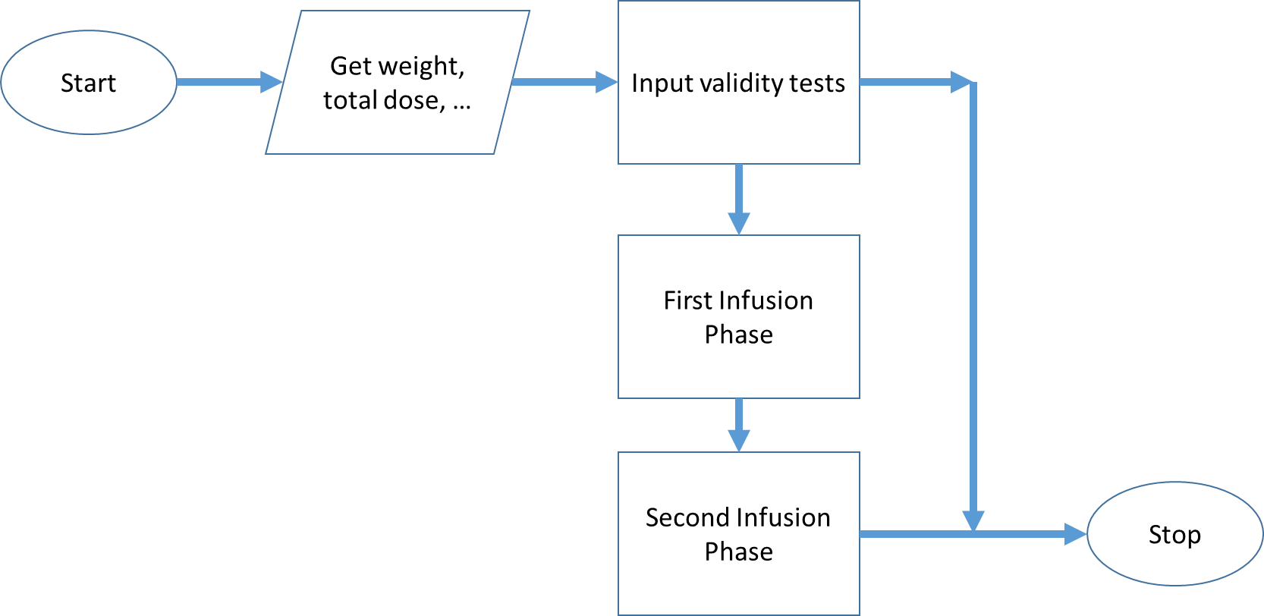

You need to create flowchart sections to do the following:

* Check the validity of the inputs
* Perform the first phase calculations
* Perform the second phase calculations

**Check for Valid Inputs Flowchart**

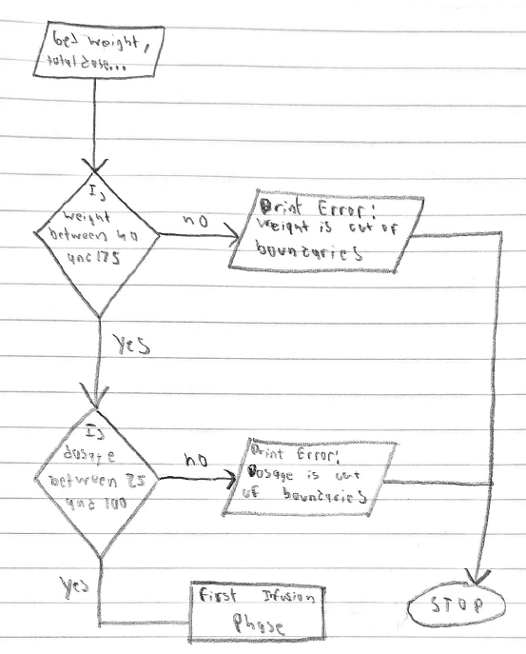

**First Phase Flowchart**

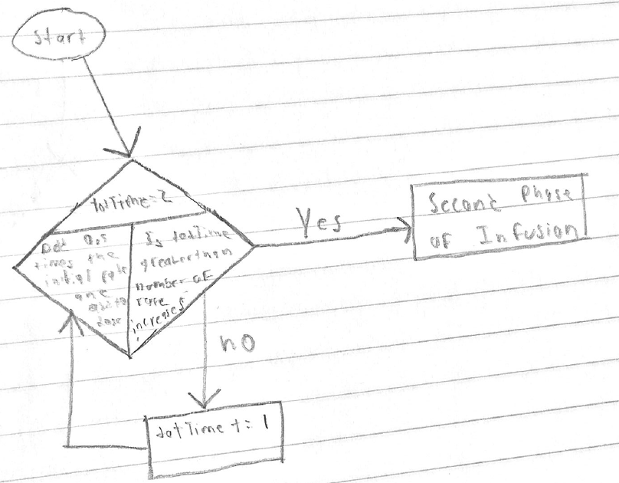

**Second Phase Flowchart**

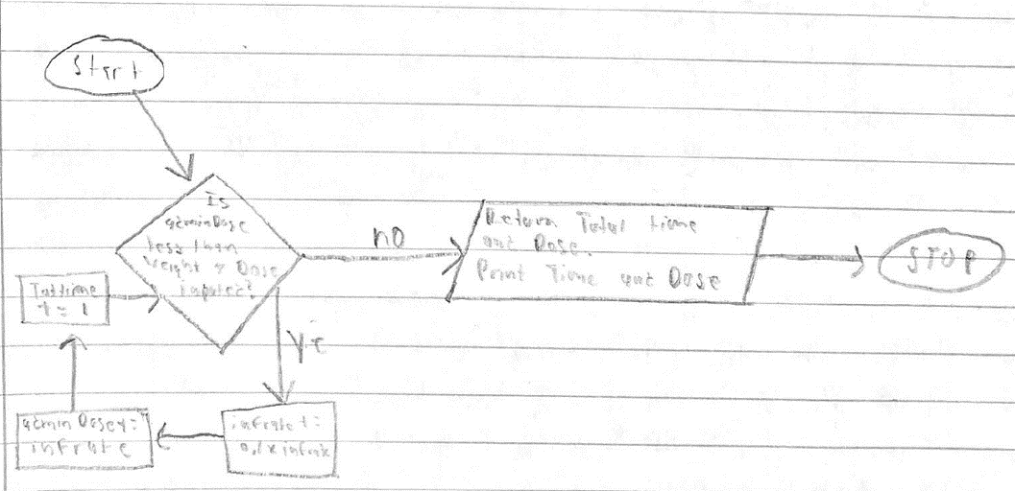

**First Phase Variable Tracking Table – by hand**

Complete the necessary parts of this table for the first phase of the infusion when dose is 25 mg/kg and patient weight is 60 kg. Add extra rows as required.

|  |  |  |  |  |
| --- | --- | --- | --- | --- |
| Iteration | Rate (mg/min) | Elapsed Time (min) | | Administered Dose (mg) |
| 0 | 75 | 1 | | 75 |
| 1 | 113 | 2 | | 188 |
| 2 | 170 | 3 | | 358 |
| 3 | 255 | 4 | 613 | |

**Second Phase Variable Tracking Table – by hand**

Complete the necessary parts of this table for the second phase of the infusion when dose is 25 mg/kg and patient weight is 60 kg. Add extra rows as required.

|  |  |  |  |
| --- | --- | --- | --- |
| Iteration | Rate (mg/min) | Elapsed Time (min) | Administered Dose (mg) |
| 0 | 255 | 4 | 613 |
| 1 | 281 | 5 | 894 |
| 2 | 309 | 6 | 1203 |
| 3 | 340 | 7 | 1543 |